In React we will create components like a function declared in a java script

Later we will execute that function as

Declare it as a tag in default in component.

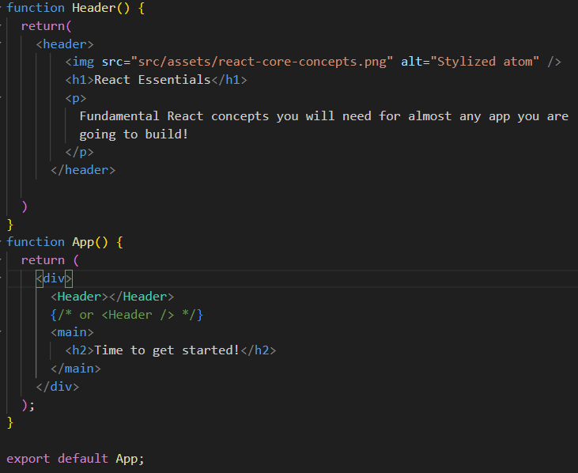

Here we created a new component as Header()

It declared in default component as a tag

<Header></Header>

      {/* or <Header /> */}

We can simply write like a forward slash as **<Header />**

Imp Concept **Map function:**

.map() is an array method that goes through each item in an array and returns a new array based on what you tell it to do. You give it a function, and it applies that function to every element.

const numbers = [1, 2, 3];

const newNumbers = numbers.map((num) => num + 1);

console.log(newNumbers); // [2, 3, 4]

**Spread Operator:**

**📘 JavaScript Spread Operator (...) – Notes**

**🔹 What is the Spread Operator?**

The spread operator (...) is used to "spread out" elements of an array or properties of an object into a new array or object.

**🔹 Syntax**

**...arrayOrObject**

**🔹 Use Cases**

**1. Copying Arrays**

const numbers = [1, 2, 3];

const copiedNumbers = [...numbers]; // [1, 2, 3]

**✅** Creates a new copy (not a reference) of the original array.

**2. Combining Arrays**

const fruits = ['apple', 'banana'];

const moreFruits = ['mango', ...fruits, 'orange'];

console.log(moreFruits); // ['mango', 'apple', 'banana', 'orange']

**✅** Inserts one array into another, keeping all elements flat.

**3. Copying Objects**

const user = { name: 'Sneha', age: 24 };

const userCopy = { ...user };

console.log(userCopy); // { name: 'Sneha', age: 24 }

**✅** Makes a shallow copy of an object.

**4. Updating Objects**

const user = { name: 'Sneha', age: 24 };

const updatedUser = { ...user, age: 25 };

console.log(updatedUser); // { name: 'Sneha', age: 25 }

**✅** Overwrites age while keeping the rest unchanged.

**5. Using in React State**

const [items, setItems] = useState([1, 2, 3]);

function addItem(newItem) {

setItems(prevItems => [...prevItems, newItem]);

}

**✅ Adds to an array without mutating original state (important for re-rendering in React).**

**🔹 Visual Example**

const arr1 = [1, 2];

const arr2 = [...arr1, 3]; // [1, 2, 3]

const obj1 = { a: 1 };

const obj2 = { ...obj1, b: 2 }; // { a: 1, b: 2 }

**⚠ Notes**

* Shallow copy only – Nested arrays/objects are still references.
* Don't use it with very large arrays inside performance-critical code.

**🧠 Memory Tip**

Think of ... like "unzipping" a bag of items and pouring them into a new container.

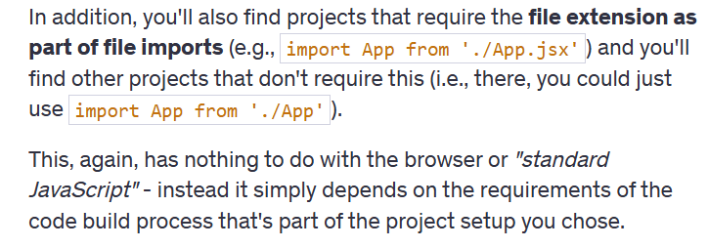

There are 2 type of components:

* Built-In Components: These are nothing but html elements, it’ll start with lower case
* Custom Components: you need start with Uppercase

Using & Outputting dynamic values:

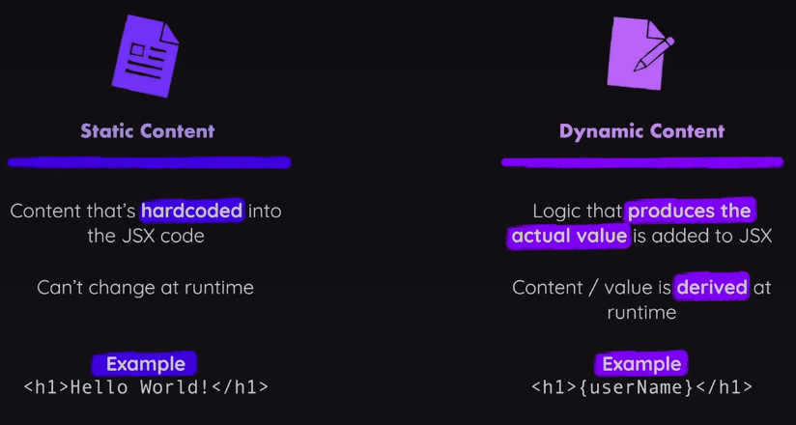

const reactDescriptions = ['Fundamental','Crucial','Core'];

function genRandomInt(max){

  return Math.floor(Math.random() * (max+1));

}

function Header() {

  return(

    <header>

        <img src="src/assets/react-core-concepts.png" alt="Stylized atom" />

        <h1>React Essentials</h1>

        <p>

          {reactDescriptions[genRandomInt(2)]} React concepts you will need for almost any app you are

          going to build!

        </p>

      </header>

  )

}

Or we can write like

Const description = reactDescriptions(getRandomInt(2));

{description}

We can use similar concept to load images in different way as below

Import reactimg from ‘./assets/react-core-concepts.png’;

<img src ={reactimg} alt = “Stylized atom” />

React allows you to pass data to components via a concept called **Props**.

It is like a read only properties that were shared between components. A Parent component can send data to a child component. Like key:value, for any integers we need to mention like {18}other than string

import componentsimg from './assets/components.png'

import jsximg from './assets/jsx-ui.png'

import propimg from './assets/config.png'

import stateimg from './assets/state-mgmt.png'

function Coreconcepts(props){

  return(

    <li>

      <img src={props.image}  />

      <h3>{props.title}</h3>

      <p>{props.description}</p>

    </li>

  )

}

function App() {

  return (

    <div>

      <Header></Header>

      {/* or <Header /> */}

      <main>

        <section id = "core-concepts">

          <h2>Core Concepts</h2>

          <ul>

            <Coreconcepts

            title="Components"

            description="The core UI building block."

            image={componentsimg}

            />

            <Coreconcepts

            title="JSX"

            description="Return (potentially dynamic) HTML(ish) code to define the actual markup that will be rendered."

            image={jsximg}

            />

            <Coreconcepts

            title="Props"

            description="Make components configurable (and therefore reusable) by passing input data to them."

            image={propimg}

            />

            <Coreconcepts

            title="State"

            description="React-managed data which, when changed, causes the component to re-render & the UI to update."

            image={stateimg}

            />

          </ul>

        </section>

        <h2>Time to get started!</h2>

      </main>

    </div>

  );

}

export default App;

o/p:

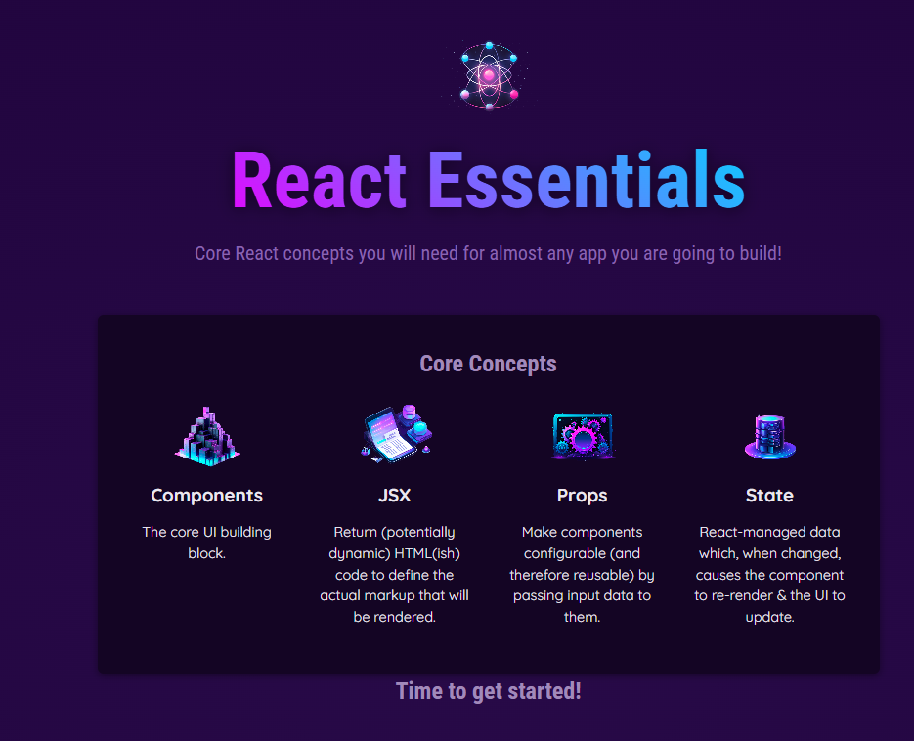 by using this props concept we displayed 4 components.

We can write in other way we will create a new file as data.js

import componentsImg from './assets/components.png';

import propsImg from './assets/config.png';

import jsxImg from './assets/jsx-ui.png';

import stateImg from './assets/state-mgmt.png';

export const CORE_CONCEPTS = [

  {

    image: componentsImg,

    title: 'Components',

    description:

      'The core UI building block - compose the user interface by combining multiple components.',

  },

  {

    image: jsxImg,

    title: 'JSX',

    description:

      'Return (potentially dynamic) HTML(ish) code to define the actual markup that will be rendered.',

  },

  {

    image: propsImg,

    title: 'Props',

    description:

      'Make components configurable (and therefore reusable) by passing input data to them.',

  },

  {

    image: stateImg,

    title: 'State',

    description:

      'React-managed data which, when changed, causes the component to re-render & the UI to update.',

  },

];

import {CORE_CONCEPTS} from './data.js'

function Coreconcepts(props){

  return(

    <li>

      <img src={props.image}  />

      <h3>{props.title}</h3>

      <p>{props.description}</p>

    </li>

  )

}

<section id= "core-concepts">

            <h2>Core Concepts</h2>

            <ul>

              <Coreconcepts

              title ={CORE_CONCEPTS[0].title}

              description={CORE_CONCEPTS[0].description}

              image={CORE_CONCEPTS[0].image}

              />

              <Coreconcepts

              title ={CORE_CONCEPTS[1].title}

              description={CORE_CONCEPTS[1].description}

              image={CORE_CONCEPTS[1].image}

              />

              <Coreconcepts

              title ={CORE_CONCEPTS[2].title}

              description={CORE_CONCEPTS[2].description}

              image={CORE_CONCEPTS[2].image}

              />

              <Coreconcepts

              title ={CORE_CONCEPTS[3].title}

              description={CORE_CONCEPTS[3].description}

              image={CORE_CONCEPTS[3].image}

              />

            </ul>

        </section>

Alternative way of approach.

Instead of writing whole component we can use directly spread operator.

<Coreconcepts {...CORE_CONCEPTS[3]}/>

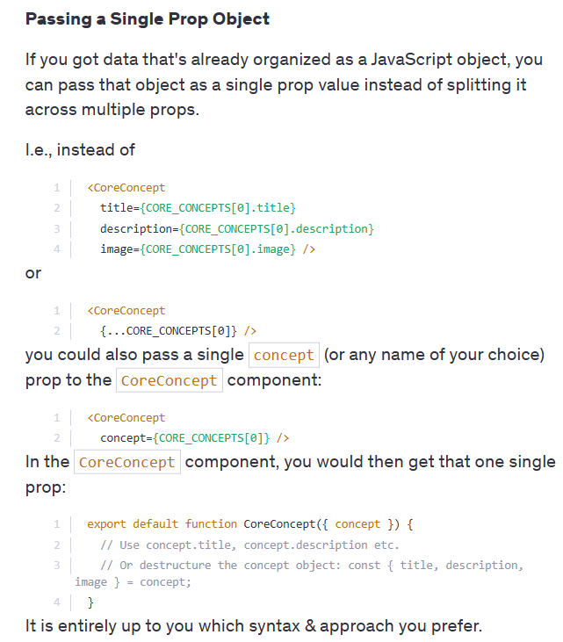

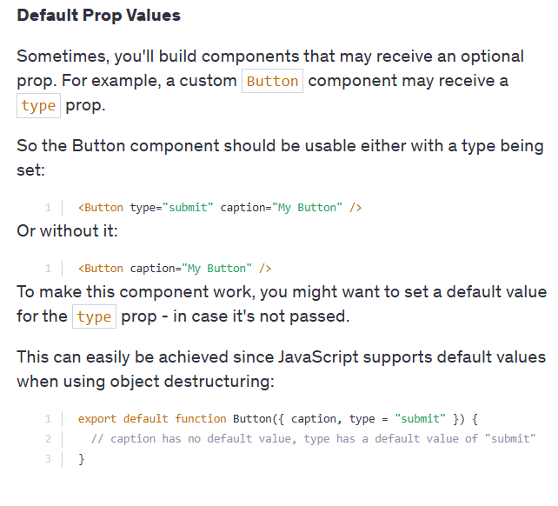

There are some limitations if you store all the header elements in a Header.jsx file and the header style properties in a separate Header.css file.

If you write any header element in the App.jsx file, its properties will also be applied to the header element in the App.jsx file

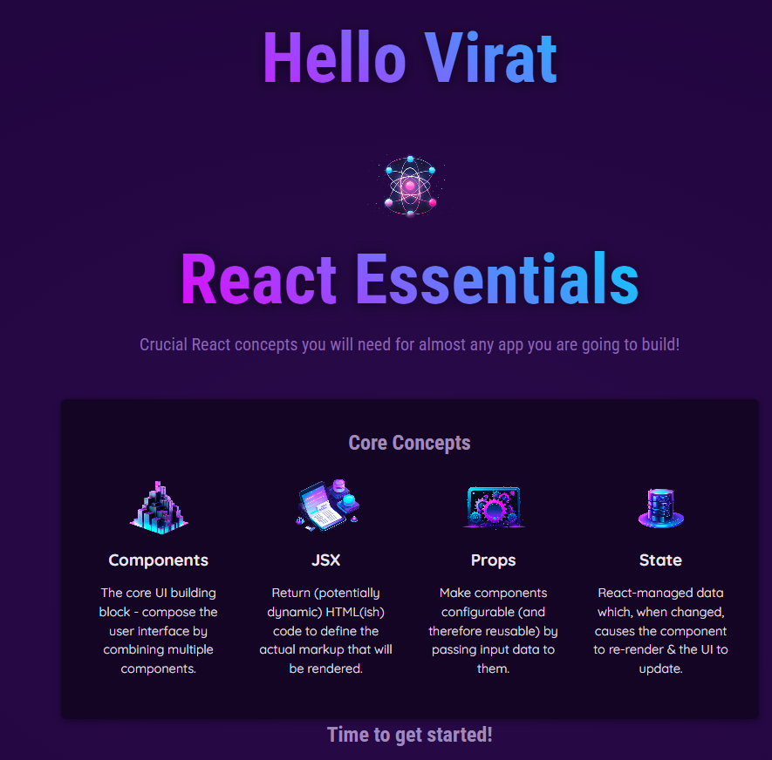 like wise React Essential properties also applied to Hello Virat

Lets Create a new examples Using children props concept

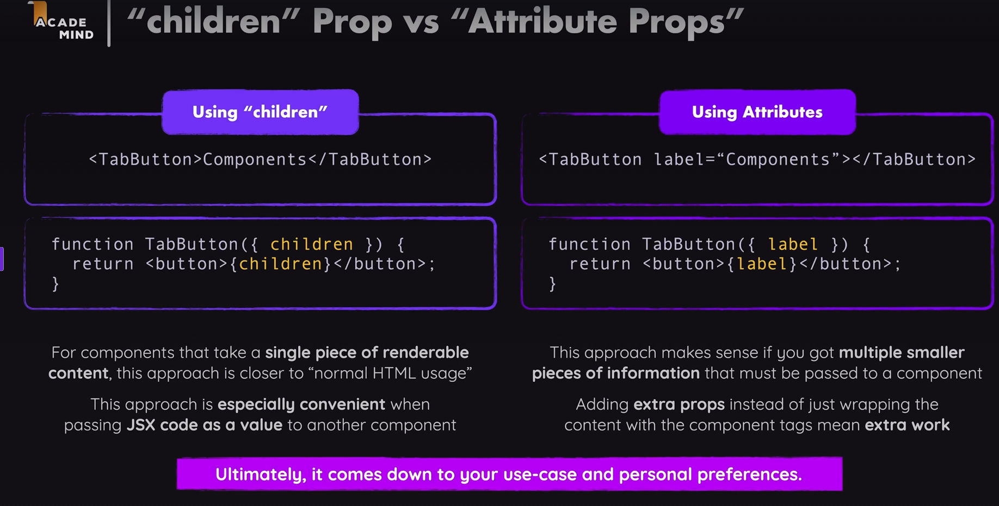

For this question   
**Component Composition**

Your task is to create a reusable Card component that takes a name prop as an input and, in addition, can be wrapped around any JSX code.

Use the already existing Card.js file to create the Card component in there. You can add the card CSS class to the main wrapping element in that component for some styling.

The name prop should be output as a title inside the Card component, the wrapped JSX code should be output below that title.

For example, the final Card component, should be usable like this:

1. <Card name="Maria Miles">
2. <p>
3. Maria is a professor of Computer Science at the University of Illinois.
4. </p>
5. <p>
6. <a href="mailto:blake@example.com">Email Maria</a>
7. </p>
8. </Card>

This should yield the following visual **output**:

Code:

import './Card.css';

function Card({ name, children }) {

return (

<div className="card">

<h2>{name}</h2>

<p>{children}</p>

</div>

);

}

export default Card;

In next concept we can use functions as values, just like we use them in props.

We need to pass only as a value not like a function

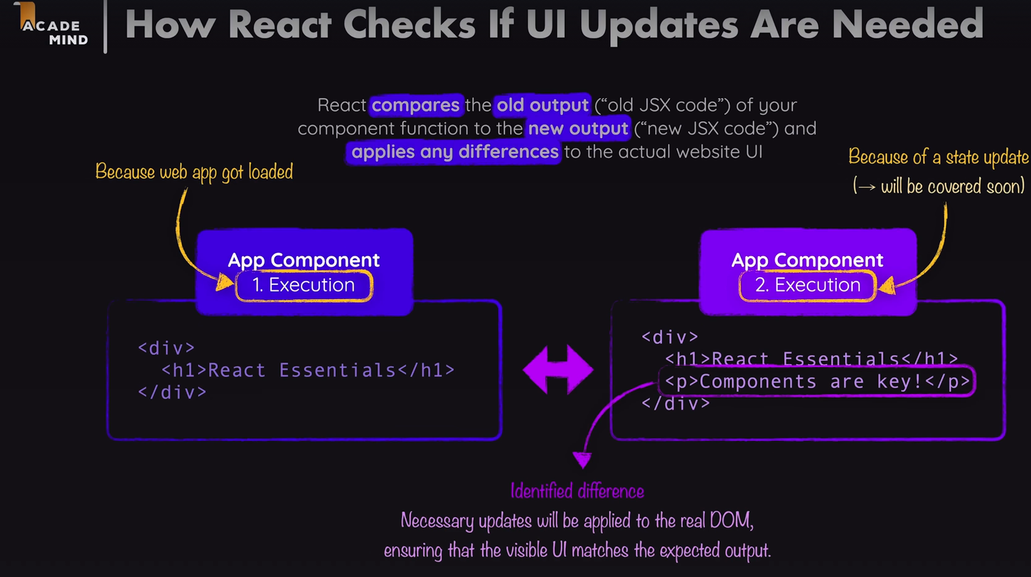

We need to remember one thing that react will only execute its component function only once.

In React, remember that each component function runs only once during its initial render. After that, React updates the component based on state or props changes without re-executing the function, ensuring efficient rendering and performance.

Eg:

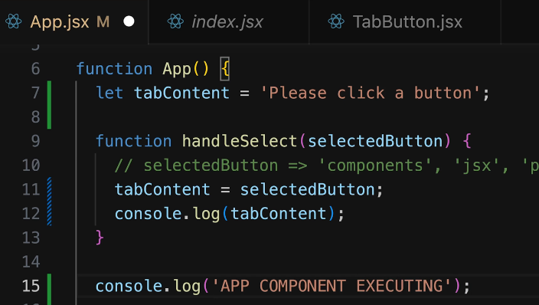 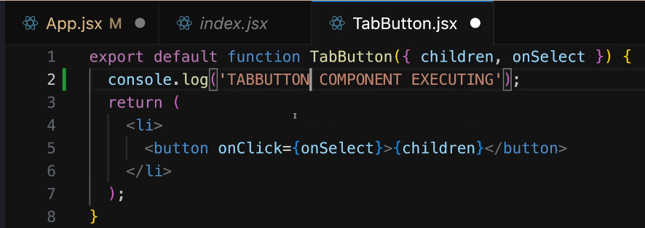

After running our project we will notice that app component will execute only 1 time where as tabButton component execute 4 times

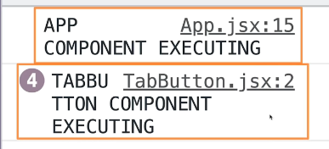

**State Concept**: We will use **useState** it is usually called as **React Hooks** (all hooks starts with use**)**.

import {useState} from 'react';

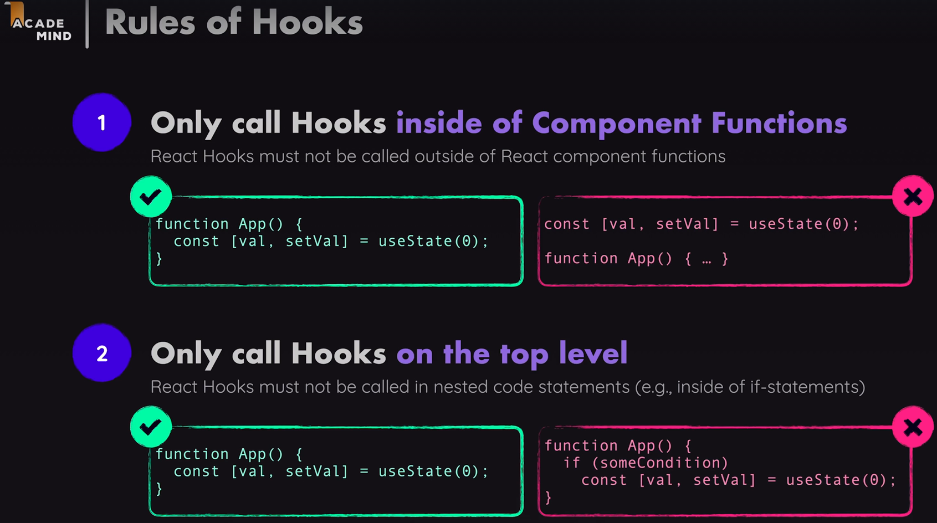 We are using this state concept to update the UI.

State is React’s way of managing dynamic data inside components. Unlike props (which are fixed once passed), state changes over time and makes components interactive.

**How our Code Uses State (useState)**

1. **Define state using useState hook:**

  const  [selectedTopic,setSelectedtopic] = useState();

* + selectedTopic is the **current state value**.
  + setSelectedTopic is the **function to update the state**.
  + The default value is undefined (no topic is selected initially).

1. **Updating state when a button is clicked:**

function handSelect(selectedButton){

    setSelectedtopic(selectedButton);

    console.log(selectedTopic);

  }

* + Clicking a **TabButton** updates the selectedTopic.
  + The console.log(selectedTopic) might not show the updated value immediately because **state updates are asynchronous** in React.

1. **Conditional Rendering Based on State:**

{!selectedTopic && <p>Please Select  a Topic.</p>}

          {selectedTopic && (<div id ="tab-content">

            <h3>{EXAMPLES[selectedTopic].title}</h3>

            <p>{EXAMPLES[selectedTopic].description}</p>

            <pre>

              <code>

                {EXAMPLES[selectedTopic].code}

        </code>

            </pre>   </div>)}

* + If no topic is selected → Show "Please Select a Topic."
  + If a topic **is** selected → Show its title, description, and example code.
  + it means if we not selected any value it will show like below
  + Moreover EXAMPLES is declared as object like key value pairs
  + 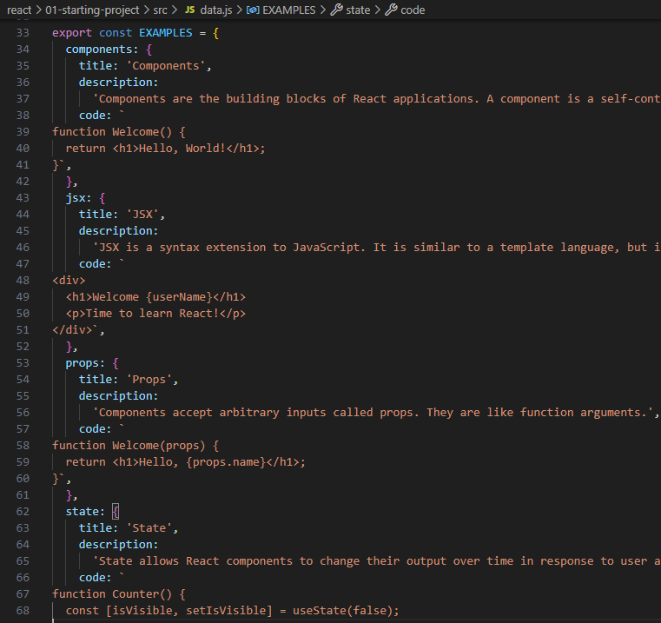
  + Output will occur as below

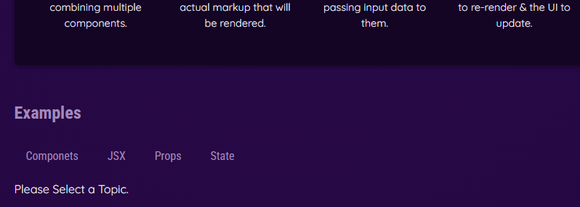

After selecting a topic

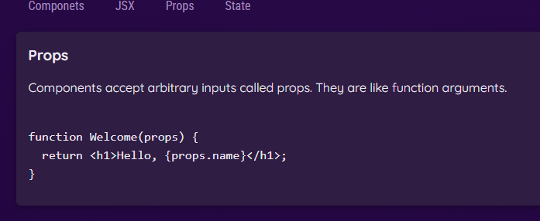

We can write in other way also Like Rendering Content Conditionally.

let tabContent = <p> Please Select A topic.</p>

  if(selectedTopic){

    tabContent = (<div id ="tab-content">

      <h3>{EXAMPLES[selectedTopic].title}</h3>

      <p>{EXAMPLES[selectedTopic].description}</p>

      <pre>

        <code>

          {EXAMPLES[selectedTopic].code}

        </code>

      </pre>

    </div>);

  }

We can execute it by calling this variable by         **{tabContent}** we will get same output as above simply by using if statement and a variable.

We can also set a conditional CSS class like we can highlight selected topic of example.

export default function TabButton({children, onSelect, isSelected}){

    return(

        <li>

            <button className = {isSelected ? 'active': undefined} onClick={onSelect}>{children}</button>

        </li>

    )

}

Here we added new prop as isSelected

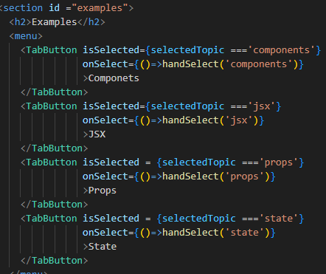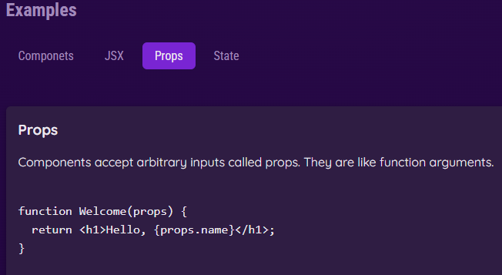

As we see props topic is highlighted this is how we can use dynamic styling through css.

In jsx class is written as **className**

**Outputting List Data Dynamically:**

We know in CORE_CONCEPTS array has 4 elements, if any 1 element has no data then our output will not occur. If number of coreconcepts elements will derive by dynamically we will get this issue.

{CORE_CONCEPTS.map((conceptItem)=>

                <Coreconcepts {...conceptItem}/>

              )}

You need to use a <div> (or any other enclosing tag) to wrap EXAMPLES data because React requires a single root element in a component’s return statement.

JSX doesn’t allow returning multiple sibling elements directly without a parent container.

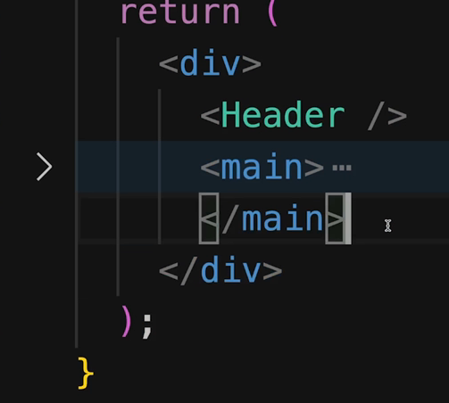 like this

Like this we can use a limitation for this Fragment(<> to </>)

Forwarding props to wrapped elements: we can use …props

The {...props} syntax is the **spread operator** used to pass down all additional properties (props) that the <Section> component receives to the underlying <Section> element.

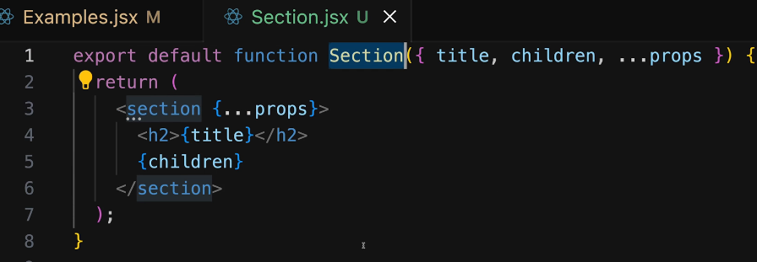

Working with Multiple JSX slots:

When building reusable React components, we often need to pass different types of content into different sections of the component. In HTML, elements like <section> and <menu> naturally contain different types of content, but in React, we need a structured way to handle this.

To achieve this, we use **props forwarding** and **multiple JSX slots** in a reusable component like Tabs.jsx.

**Why Use Multiple JSX Slots?**

**Problem with a Single Children Prop**

React components typically use children to receive content, but when we need **multiple separate content areas**, such as:

* A tab menu (buttons)
* A tab content area

We need more than just children. If we only rely on children, we lose flexibility.

**Solution: Pass JSX Code as Props**

Instead of just using children, we define **additional named props** to pass JSX content to different areas.

**Implementing the Tabs Component**

**Creating Tabs.jsx**

We create a reusable Tabs component that enforces a structure:

* **A <menu> for buttons**
* **A section below for dynamic content**

**Using the Tabs Component in Examples.jsx**

**Before (Without Slots)**

**Originally, the tab buttons and content were in the same component, making it less reusable.**

**After (With Slots)**

**Now, we pass tab buttons separately while keeping content inside Tabs.**

export default function Tabs({children,buttons}){

    return(

    <>

      <menu>{buttons}</menu>

      {children}

    </>

    );

}

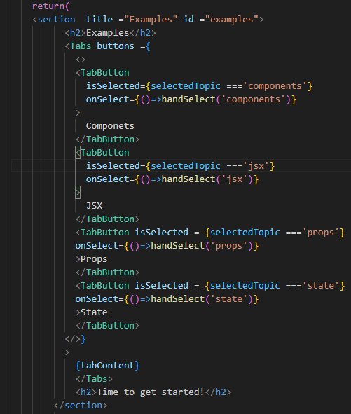

**Setting Components with Dynamic Types in React**

**1️ The Concept: Dynamic Component Wrappers**

* In React, you may want to dynamically set the wrapper element around certain UI elements.
* Instead of hardcoding an element (e.g., <menu> or <div>), we can allow the developer to choose which HTML element or custom component should be used.
* This is useful in larger applications where a component may be reused in different contexts.

**2️ How It Works**

* We pass a component identifier (either a built-in element like "menu" or "div" or a custom component) as a prop.
* React will determine whether to render a built-in HTML element or a custom React component based on the value of this prop.

Example:

export default function Tabs({children,buttons,buttonsContainer}){

    const ButtonsContainer = buttonsContainer;

    return(

    <>

      <ButtonsContainer>{buttons}</ButtonsContainer>

      {children}

    </>

    );

}

**<Tabs buttonsContainer="menu" buttons={...} />**

Like wise

For Custom Components: Custom components must be passed as a dynamic value (without quotes) because they are React functions.

**<Tabs buttonsContainer={Section} buttons={...} />**

**Imp points:**

* Built-in elements (menu, div, ul) must be passed as a string.
* Custom components must be passed as a variable (without quotes).
* The prop should be mapped to an uppercase-named variable (ButtonsContainer) so that React treats it as a component.

**Setting Default Prop Values:**

We can use built in elements manually without enter it dynamically.

**What Are Default Prop Values?**

* Default prop values allow a React component to have a fallback value **if a prop is not provided**.
* This makes the component more **flexible** and **user-friendly** by ensuring it still functions without explicitly passing all props.

**2️ How to Set Default Prop Values?**

* When using destructuring in function parameters, we can set a default value using =.

🔹 Example: Setting Default Prop Value for buttonsContainer

export default function Tabs({children,buttons,buttonsContainer='menu'}){

Defaulting it to a Custom Component

export default function Tabs({children,buttons,buttonsContainer=Section}){

In Tabsjsx we can’t need to pass buttonsContainer

Since buttonsContainer is not explicitly passed, it will default to 'menu' (or the Section component, depending on how it was set in Tabs)

🔹 🔐 Component Isolation in React

What it means:  
Each time you use a component like <Player />, it gets its own private state and logic.

Key Points:

* Components don’t share state, even if they use the same code.
* Example:

<Player name="Player 1" />

<Player name="Player 2" />

Each has its own isEditing state.

Why it matters:

* Clicking "Edit" on Player 1 won’t affect Player 2.
* Makes components reusable and helps avoid side effects.
* React creates a separate instance for each component use.

🔄 Updating State Based on Previous Value

If the new state depends on the previous value, always use a function form:

setIsEditing(prev => !prev) // ✅ safest toggle

Why not just setIsEditing(!isEditing)?

* It might work, but React state updates are asynchronous.
* You could get outdated values if updates happen quickly.

✅ Summary: Toggling isEditing

| Code | What it does |
| --- | --- |
| if (!isEditing) | Just checks value (no update) |
| setIsEditing(!isEditing) | Updates state (can be buggy) |
| setIsEditing(prev => !prev) | Safely toggles using latest value |

🧠 Bonus: Arrow Function Parentheses

* You don’t need () around one parameter:

setIsEditing(prev => !prev)

* Use () when:
  + You have multiple parameters: (x, y) => x + y
  + You want clear readability: (prev) => !prev

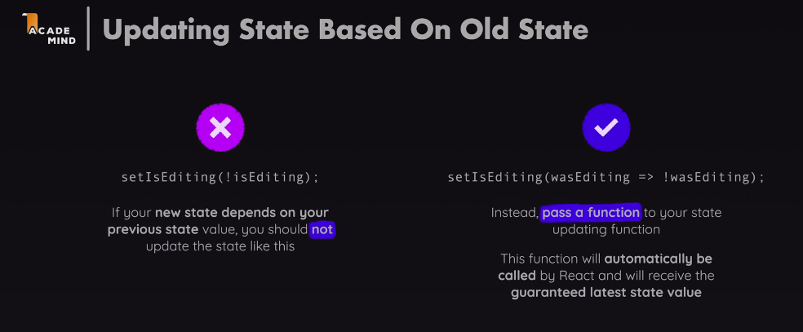

In React, when updating state, especially when the new state depends on the **previous state**, it's recommended to use a **function** inside setState.

If you're toggling state in React, you might think writing setIsEditing(!isEditing) is fine. But there's a catch! React updates state asynchronously, so isEditing might not always have the latest value when the update happens. This can lead to unexpected behavior, especially if multiple updates happen quickly.

Instead, using setIsEditing(wasEditing => !wasEditing) is the safer way. It ensures you're always working with the most up-to-date state, preventing any weird bugs.

✅ **Final Summary:**

| Code | What it does |
| --- | --- |
| **if (!isEditing)** | Just checks the value (read-only) |
| **setIsEditing(!isEditing)** | Updates state (can work, but risky with async) |
| **setIsEditing(prev => !prev)** | Safely toggles the state using latest value |
| **setIsEditing((prev) => !prev)** | Same as above, with optional parentheses |

Bottom line: When your new state depends on the old state, always use the function version! 🚀

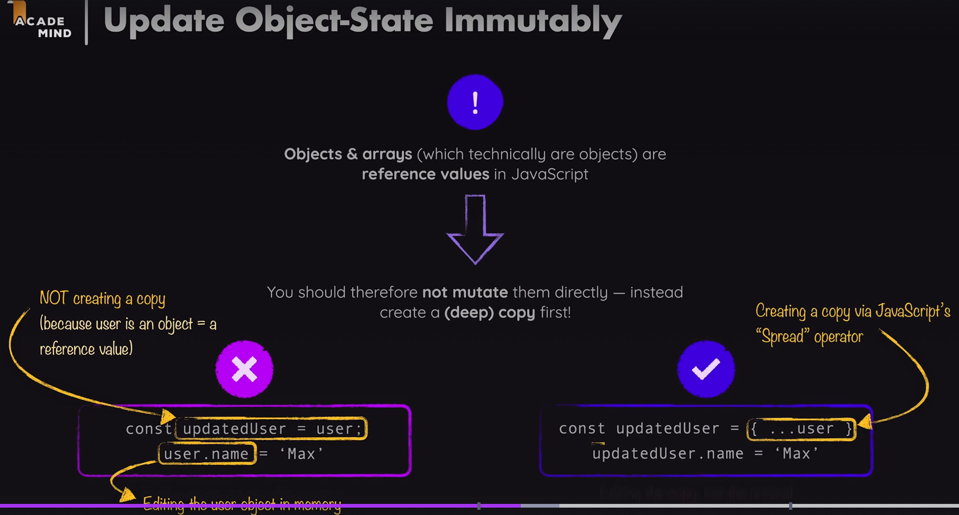

**Key concept: Objects & Arrays are Reference Values**

* In JavaScript, objects and arrays are stored by reference in memory.
* If you assign an object to a new variable without copying it, both variables point to the same memory location.

**Wrong Approach (Mutating State Directly)**

const updatedUser = user;

updatedUser.name = 'Max';

* Here, updatedUser is **not a new object**, but just another reference to user.
* Changing updatedUser.name also **modifies the original user object** in memory.
* **This is bad for React state**, as React might not detect the change and rerender properly.

**Correct Approach (Immutable Update using Spread ...)**

const updatedUser = { ...user };

updatedUser.name = 'Max';

* { ...user } creates a shallow copy of the user object.
* Now, updatedUser is a new object in memory.
* Modifying updatedUser.name does not affect the original user object.
* React can now detect the change and update the UI properly.

**Why do we need to use the spread operator instead of assigning directly?”**

**📝 React Notes: Reference vs Copy (Spread Operator)**

**🌟 1. Direct Assignment = Shared Reference**

const user = { name: 'Sneha', age: 22 };

const updatedUser = user;

updatedUser.name = 'Max';

**What happens?**

* Both user and updatedUser now point to the **same object**.
* Changing one will affect the other.

console.log(user.name); // 'Max' 😱

**✅ 2. Spread Operator = New Copy**

const user = { name: 'Sneha', age: 22 };

const updatedUser = { ...user };

updatedUser.name = 'Max';

console.log(user.name); // 'Sneha' ✅

console.log(updatedUser.name); // 'Max' ✅

...user copies all key-values into a **new object** — no link to the old one.

**⚠️ 3. Why it matters in React**

React updates the UI **only** if state changes — and it checks by **reference**.

setUser(user); // React says: "Same object? No update."

But:

setUser({ ...user }); // React: "New object? Re-render! ✅"

**🧠 4. Works for arrays too**

const oldArray = [1, 2, 3];

const newArray = [...oldArray];

newArray[0] = 9;

console.log(oldArray); // [1, 2, 3]

console.log(newArray); // [9, 2, 3]

**🔄 5. Copying Nested Arrays (e.g. Game Board)**

For 2D arrays like Tic-Tac-Toe:

const newBoard = oldBoard.map(row => [...row]);

* This copies **each inner array** too
* Helps avoid bugs and ensures React sees a real change

**🎯 Summary Table**

| **What You Do** | **What It Means** |
| --- | --- |
| const b = a | Reference only (linked) ❌ |
| const b = { ...a } | New object (safe) ✅ |
| const b = [...a] | New array (safe) ✅ |
| a.map(row => [...row]) | Deep copy of 2D array ✅ |
| Mutate original | Breaks React reactivity ❌ |
| Copy → Then mutate | React-friendly ✅ |
| In React, changing what's *inside* an object/array isn't enough — you must create a new one to trigger updates. |  |

**Why and What Happens in** const updatedBoard = prevGameBoard.map(row => [...row])

**🎯 Goal:**

We want to update our Tic-Tac-Toe game board safely without breaking React’s re-render system.

**✅ What does this line do?**

const updatedBoard = prevGameBoard.map(row => [...row]);

It creates:

* A **new outer array**
* With **copied inner arrays** (new memory)
* So we can safely modify it like:

updatedBoard[row][col] = 'X';

**🧠 Why not just assign directly?**

const updatedBoard = prevGameBoard; // ❌ Bad

* This creates a **reference**, not a copy.
* Changing updatedBoard also changes prevGameBoard.
* React might not re-render the UI — because the reference is the same!

**✅ Why this works**

* map() goes through each row of the board.
* [...] (spread) creates a **copy of each row**.
* The result is a **fully new board**, like this:

[

[null, null, null], // new row

[null, null, null], // new row

[null, null, null] // new row

]

Now React sees:

“Hey! New array! I should re-render!” ✅

**⚠️ React compares by reference, not content**

Even if you change the contents, if you return the same object, React says:

if (newState === oldState) {

// Looks the same to me, skip re-render!

}

So you must return a new object → new memory → re-render.

**🔁 Summary Table**

| **Code** | **What Happens** | **React Re-render?** |
| --- | --- | --- |
| const b = a | b points to same array ❌ | ❌ No |
| const b = a.map(row => [...row]) | b is a new 2D array (deep copy) ✅ | ✅ Yes |

**🎓 Rule to Remember**

**In React, always copy arrays/objects before updating — never change them directly.**

**🔼 What is “Lifting State Up” in React?**

In React, **"lifting state up"** means:

Moving state to the **nearest common parent component** of two or more child components that need to share or coordinate behavior/data.

**difference between using deriveActivePlayer() vs. useState** for tracking the current player in your React Tic-Tac-Toe app.

**🔁 Using deriveActivePlayer(gameTurns) (Stateless Derivation)**

**✅ What it does:**

* Calculates **active player dynamically** from gameTurns (which stores all past moves).
* No need to manage a separate activePlayer state.

**🧠 How it works:**

function deriveActivePlayer(gameTurns){

  let currentPlayer = 'X';

      if(prevTurns.length >0 &&prevTurns[0].player ==='X'){

        currentPlayer = 'O';

      }

      return currentPlayer;

}

**🧩 In App Component:**

const[gameTurns,setGameTurns] =useState([]);

const activePlayer = deriveActivePlayer(gameTurns);

**🎯 Benefits:**

* **No extra state to manage.**
* Always reflects current game status.
* Less room for bugs like desync between turn and board.

**🚫 Downsides:**

* Runs the function on **every render** (but it's very lightweight, so usually fine).

**🧍‍♂️ Using useState('X') to track active player**

**✅ What it does:**

* Maintains activePlayer in component state.
* Manually toggles between 'X' and 'O' after each turn.

**🧠 How it works:**

const [activePayer,setActivePlayer] = useState('X');

function handleSelectSquare(row, col) {

setActivePlayer(prev => prev === 'X' ? 'O' : 'X');

setGameTurns(...); // update turns separately

}

**🎯 Benefits:**

* Easy to understand and control.
* Doesn't require checking gameTurns to know whose turn it is.

**🚫 Downsides:**

* **State duplication** — managing activePlayer **and** gameTurns can lead to inconsistency.
* More code, slightly more chance for bugs.

**🏁 Which one should *you* use?**

| **Feature** | **deriveActivePlayer** | **useState('X')** |
| --- | --- | --- |
| Sync with turns | ✅ Always accurate | ❌ Can desync |
| Extra state needed | ❌ No | ✅ Yes |
| Cleaner logic | ✅ Yes | ❌ More manual work |
| Ideal for | Functional React style | Simple logic apps |

**🔥 TL;DR**

* Use deriveActivePlayer(gameTurns) if you want **clean, stateless logic** based on game history.
* Use useState if you're building something very simple and want manual control.

**✅ Project: React Tic Tac Toe Game — Summary & Notes**

**🧱 Components You Built**

1. **App.jsx**
   * Main component that holds the core state and game logic.
   * Derives:
     + Current player (X or O)
     + Winner
     + Game board from gameTurns
     + Game over or draw condition
2. **Player.jsx**
   * Displays player name and symbol (X or O)
   * Editable player name input with internal state
   * On save, updates name in App via a prop function (onNameChange)
   * Uses two-way binding for editable input
3. **GameBoard.jsx**
   * Renders a 3x3 grid of buttons
   * Highlights current turn and disables already-filled squares
   * Gets onSelectSquare and board from App
4. **Log.jsx**
   * Displays a history of all moves made
   * Pulled from gameTurns state in App
5. **GameOver.jsx**
   * Shown when someone wins or it’s a draw
   * Displays message like X won! or It's a draw!
   * Includes **"Rematch"** button to reset the game

**⚙️ State Variables in App.jsx**

* gameTurns:  
  Stores all moves as an array of {square: {row, col}, player: 'X'|'O'}  
  → **Single source of truth** from which the board, current player, and winner are all derived.
* playerNames:  
  { X: "Player 1", O: "Player 2" }  
  Updated via handlePlayerNameChange(symbol, newName).

**🔁 Key React Concepts You Used**

* **State & Props**
* **Lifting state up**: Moved player names from Player to App so the winner display could access them.
* **Derived state**:
  + Active player is **calculated**, not stored.
  + Board is **derived** from turns, not stored separately.
* **Two-way binding**: Input reflects state, and changes update state.
* **Event handling**: onClick, onChange
* **Conditional rendering**: winner && <GameOver />

**💡 JavaScript Concepts You Used**

**🧠 Arrays and Objects Are Reference Types**

* You originally did:

let gameBoard = initialGameBoard;

Then modified it:

gameBoard[row][col] = player;

❗ This **mutated** the original array, causing bugs on rematch.

* ✅ Fixed with deep copy:

let gameBoard = initialGameBoard.map(row => [...row]);

**🛠 Spread Operator:**

* Used to safely clone or update objects/arrays:

setPlayerNames(prev => ({

...prev,

[symbol]: newName

}));

**🔍 Object Mapping:**

* You used { X: "Player 1", O: "Player 2" } to tie player names to symbols.

**🧠 Conditional Logic:**

* To prevent extra moves after a winner:

if (hasWinner) return;

* To check draw:

const hasDraw = gameTurns.length === 9 && !winner;

**🔄 Game Flow**

1. Game starts with empty board.
2. User clicks a square → move is logged in gameTurns.
3. Board updates via derived data from gameTurns.
4. Winner is checked after every move.
5. If all squares are filled and no winner → draw.
6. GameOver screen shows with winner or draw message.
7. Clicking "Rematch" resets gameTurns, and everything resets.

**🧪 Bonus Improvements You Can Add**

* Highlight winning squares ✨
* Score counter across rounds 🏆
* AI opponent 🤖
* Timer per move ⏱️
* "Best of 3" mode

**Tic Tac Toe Build Pattern — Step-by-Step Timeline**

**🔹 Step 1: App.jsx + Static UI Layout**

* Created basic JSX structure inside <App />:
  + <h1> heading
  + Game container
  + <Player /> components
  + Placeholder for GameBoard and Log

**🔹 Step 2: Created Player.jsx Component**

* Displayed player name and symbol:

<Player name="Player 1" symbol="X" />

* Hardcoded a button inside to test edit/save

**🔹 Step 3: Created GameBoard.jsx**

* Rendered a 3x3 grid using nested .map()
* Created dummy buttons without logic

**🔹 Step 4: Created Log.jsx**

* Added a basic unordered list (<ul>)
* Later used this to display each move made

**🔹 Step 5: Added gameTurns state in App.jsx**

const [gameTurns, setGameTurns] = useState([]);

* Used this to store all moves
* Passed onSelectSquare to GameBoard

**🔹 Step 6: Derived activePlayer from turns**

function deriveActivePlayer(turns) {

return turns.length > 0 && turns[0].player === 'X' ? 'O' : 'X';

}

* Removed separate activePlayer state
* Used derived logic instead (React best practice!)

**🔹 Step 7: Derived gameBoard from turns**

let gameBoard = initialGameBoard.map(row => [...row]);

for (const turn of gameTurns) {

gameBoard[row][col] = player;

}

* Learned why shallow copying fails
* Fixed mutation bug with .map(row => [...row])

**🔹 Step 8: Winner detection logic**

for (const combination of WINNING_COMBINATIONS) {

// Check 3 squares

}

* Derived winner inside App every render
* Avoided extra state by re-calculating from gameBoard

**🔹 Step 9: Added GameOver.jsx component**

* Displayed "X won!" or "It's a draw!"
* Included **Rematch** button

**🔹 Step 10: Added handleRestart() in App.jsx**

function handleRestart() {

setGameTurns([]);

}

* Passed onRestart to GameOver
* Fixed board mutation with deep copy of initialGameBoard

**🔹 Step 11: Moved player name state to App.jsx**

const [playerNames, setPlayerNames] = useState({

X: 'Player 1',

O: 'Player 2',

});

* Learned about **lifting state up**
* Added handlePlayerNameChange(symbol, newName) in App

**🔹 Step 12: Updated Player.jsx for two-way binding**

* Used local useState for editable input
* Called onNameChange only on Save (not every keystroke)
* React performance tip: keep typing state local to avoid unnecessary re-renders

**🧠 Concepts You Practiced Along the Way**

| **Concept** | **How You Used It** |
| --- | --- |
| useState | for gameTurns, playerNames, input fields |
| Derived state | active player, board, winner |
| useEffect (optional) | could sync local input if needed |
| Lifting state | moved names from Player → App |
| Spread operator | for immutably updating objects |
| Reference types | fixed bugs caused by shared array references |
| Two-way binding | input reflects + updates state |
| Conditional rendering | winner / draw / rematch buttons |

**🧾 React Investment Calculator – Project Notes**

**💡 Goal:**

Build a modular React app that:

* Takes in user input for investment parameters
* Calculates compound interest over multiple years
* Displays the year-by-year breakdown in a table

**🧭 Project Structure & Flow**

App.jsx

├── Header.jsx → Displays app title and logo

├── UserInput.jsx → Form inputs (initial, annual investment, return %, duration)

├── Results.jsx → Table with calculated values using utility functions

└── investment.js → Contains business logic for compound interest calculation

**✅ Concepts Learned & Applied**

| **Concept** | **Description** |
| --- | --- |
| **useState** | Store form input values in a single state object (userInput) |
| **Controlled Components** | Each <input> has value={...} and onChange={...} |
| **Lifting State** | Form state lives in App, passed down to UserInput |
| **Prop Drilling** | Passed userInput and handleChange as props to child components |
| **Conditional Rendering** | Show either error or results depending on input validity |
| **Modular Components** | Header, UserInput, and Results are reusable and separated |
| **Utility Functions** | calculateInvestmentResults() in a separate file handles math |
|  |  |

**Styling React Apps:**

Static & Dynamic Styling for apps

Styling react with vanilla css.

Scoping styles with css modules

Css in js styling with styled components

Styling with tailwind css

We are applying **inline styles in React** using the style attribute.

Inline styles are only effect on JSX

Unlike HTML, which accepts CSS strings like

<p style ={{

        color:"red",

        textAlign:"right"

      }}>A community of artists and art-lovers.</p>

**🧠 Key Concepts Behind React Inline Styles**

| **Concept** | **Explanation** |
| --- | --- |
| **JSX style prop** | Accepts a JavaScript object — not a string |
| **CamelCase property names** | text-align becomes textAlign, background-color becomes backgroundColor |
| **Values are strings or numbers** | "red" is valid, as is 20 for pixel values |
| **Double curly braces {{ }}** | Outer braces = JSX expression, inner braces = style object |

**🧾 What Each Property Does:**

| **Property** | **Description** |
| --- | --- |
| color: "red" | Sets the text color to red |
| textAlign: "right" | Aligns the text to the right side |

**✅ When to Use Inline Styles in React**

| **Use Case** | **✅ Good** | **❌ Not Ideal** |
| --- | --- | --- |
| Quick one-off styling | ✅ |  |
| Dynamically changing styles via props | ✅ |  |
| Theming, hover effects, media queries |  | ❌ Better to use CSS or CSS-in-JS |

**🧠 Tip: Best Practices**

* Use inline styles **for dynamic styles** that depend on state or props.
* For global layout and appearance, use **external CSS or CSS modules** (like Header.css in your example).
* Avoid overusing inline styles as they don’t support media queries, pseudo-classes like :hover, etc.

**React styling concept**: **conditional styling** using CSS class names.

**✅ Adding a class conditionally**

He uses this:

className={condition ? 'invalid' : undefined}

Why undefined? Because React will **not apply the class** if it’s undefined.  
If you accidentally write:

className={condition && 'invalid'}

Then when condition is false, className=false gets applied — and you’ll see a React warning:

"Warning: Received false for a non-boolean attribute className"

**✅ Merging multiple class names conditionally**

If you have a **base class that should always apply**, and another one only sometimes, use a **template string (backticks)**:

className={`label ${emailNotValid ? 'invalid' : ''}`}

This renders as:

class="label invalid" // when condition is true

class="label" // when condition is false

✅ So label is always there, and invalid gets added only if emailNotValid is true.

**✅ Why use backticks (template literals)**

Backticks let you inject variables dynamically into a string:

const isError = true;

const className = `form-field ${isError ? 'error' : ''}`;

Equivalent to:

class="form-field error"

Concept Summary

Inline styles Use for very small tweaks, not scalable for big apps

Class-based styling Use CSS classes for complex styling or conditional classes

Ternary for conditional classes className={condition ? 'className' : undefined}

Merging classes Use backticks: className={`base ${condition ? 'extra' : ''}`}

Avoid && shortcut Because it can apply false as a class and cause React warnings

Invalid field example Show .invalid class only when a field is submitted and invalid

If we mistakenly use the && shortcut instead of a ternary operator when applying a class conditionally, we may get a warning in the console because false can be passed as a class name. This happens when the condition is false — React tries to apply false as a class, which is invalid.  
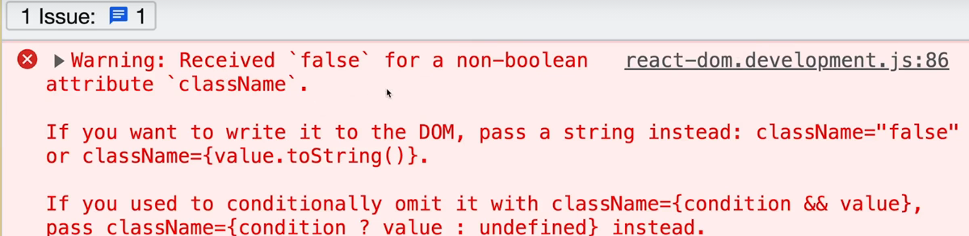

**📘 Notes: Styling in React — Vanilla CSS vs. CSS Modules**

**🧠 1. Regular CSS (Vanilla CSS)**

**How it works:**

* You write styles in a global .css file (like Header.css)
* Import it using import './Header.css'
* Use classes or tags like <p> in the CSS

**Example:**

p{

    text-align: center;

  }

This limits the scope a bit, but still not component-safe.

**✅ 2. CSS Modules**

**What it is:**

* A way to write **scoped CSS for React components**
* File names end with .module.css
* Classes are **transformed into unique names** during build

**Benefits:**

| **✅ Advantage** | **📄 Description** |
| --- | --- |
| Scoped styles | Styles only apply to the component importing them |
| Avoid name collisions | Class names are transformed (e.g., button_a2c3x) |
| Write normal CSS | No new syntax to learn like styled-components |
| Easy conditional logic | Use JS logic like className={isInvalid ? styles.red : ''} |

**🔄 When to Use What?**

| **Scenario** | **Use Vanilla CSS** | **Use CSS Modules** |
| --- | --- | --- |
| One-off app, small project | ✅ | ✅ |
| Shared global styling (reset/base) | ✅ | ❌ |
| Component-level, scoped styling | ❌ | ✅ |
| Large teams/projects | ❌ | ✅ |

**💬 Final Thought:**

CSS Modules give you the **power of scoped styles** with the **simplicity of plain CSS** — a perfect balance for many React projects.

**🔹 Tailwind CSS – Full Summary Notes**

**1. What is Tailwind CSS?**

* A utility-first CSS framework.
* Lets you style elements directly in your JSX/HTML via utility class names (e.g., bg-red-500, mt-4, text-center).
* It is not React-specific but integrates very well with React.

**2. Basic Setup (Vite-based Project)**

* Install Tailwind:

npm install -D tailwindcss postcss autoprefixer

npx tailwindcss init -p

* Edit tailwind.config.js:

export default {

  content: ["./index.html", "./src/**/*.{js,ts,jsx,tsx}"],

  theme: {

    extend: {},

  },

  plugins: [],

};

In index.css:

@tailwind base;

@tailwind components;

@tailwind utilities;

**3. Key Tailwind Concepts**

* **Utility Classes**: One class = one styling rule (e.g., p-4 = padding).
* **Responsiveness**: Mobile-first by default. Use prefixes: md:, lg: etc.
* **Dark Mode**: Add dark: prefix or enable in tailwind.config.js.
* **Hover & Focus**: Use hover: or focus: prefixes like hover:bg-blue-500.
* **Gradients**: bg-gradient-to-r from-blue-500 to-indigo-700.

**4. Styling React Components with Tailwind**

* Tailwind classes go directly in the className attribute:

<button className="bg-blue-500 hover:bg-blue-700 text-white py-2 px-4 rounded">

  Click me

</button>

**5. Custom Fonts & Colors**

* Import custom fonts in index.html (e.g., from Google Fonts).
* Extend Tailwind in tailwind.config.js:

theme: {

  extend: {

    fontFamily: {

      title: ['"Your Font"', 'cursive'],

    },

  },

}

Then use: className="font-title"

**6. Conditional & Dynamic Styling**

* You can apply styles conditionally:

const labelClasses = `text-sm font-bold ${invalid ? 'text-red-400' : 'text-stone-300'}`;

For dynamic styles in input:

const inputClasses = `w-full px-2 py-1 rounded bg-stone-200 ${invalid ? 'border-red-300 bg-red-100 text-red-500' : 'border-stone-300 text-stone-800'}`;

**7. Reusable Component Strategy**

* Create wrapper components for repeated structures like Input, Button, etc.
* Keep JSX clean by pushing class logic into reusable components.

**8. Tailwind IntelliSense Setup**

Ensure VS Code suggestions work:

* Install **Tailwind CSS IntelliSense** extension.
* In settings.json:
* {
* "tailwindCSS.includeLanguages": {
* "javascript": "javascriptreact",
* "typescript": "typescriptreact"
* },
* "editor.quickSuggestions": {
* "strings": true
* },
* "emmet.includeLanguages": {
* "javascript": "javascriptreact"
* }
* }

**9. Pros & Cons**

**Pros:**

* No need to write or manage external CSS files.
* Super fast UI building once familiar.
* Prevents naming collisions and CSS scope issues.
* Highly customizable.
* Great dev experience with IntelliSense.

**Cons:**

* JSX gets cluttered with many class names.
* Requires learning a new set of class utilities.
* Less separation of concerns (JSX + CSS mixed).
* Sometimes overkill for small projects.

**comparison** of **Vanilla CSS vs Styled Components vs Tailwind CSS**

**🔰 1. Syntax & Style Application**

| **Feature** | **Vanilla CSS** | **Styled Components** | **Tailwind CSS** |
| --- | --- | --- | --- |
| How styles are applied | External .css files or <style> tags | Styled React components via template literals | Utility class names in className attributes |
| Example | .btn { color: red; } → <button class="btn"> | const Btn = styled.button color: red;`` → <Btn>` | <button className="text-red-500"> |
| Style location | Separate CSS files | Co-located in component | In JSX as utility classes |

**🔰 2. Componentization & Reusability**

| **Feature** | **Vanilla CSS** | **Styled Components** | **Tailwind CSS** |
| --- | --- | --- | --- |
| Scoped styles | ❌ No (needs BEM/naming conventions) | ✅ Yes (auto-scoped to components) | ✅ Yes (class utility is local to element) |
| Reusability | Manual (create classes) | Very high (just reuse the styled component) | Moderate (wrap utility-heavy elements into components manually) |
| Custom logic (props) | ❌ Not supported | ✅ Dynamic styles via props | ✅ Achievable via template strings / conditionals |

**🔰 3. Learning Curve & Tooling**

| **Feature** | **Vanilla CSS** | **Styled Components** | **Tailwind CSS** |
| --- | --- | --- | --- |
| Learning Curve | Low (just CSS) | Medium (JS template literals + CSS-in-JS) | Medium (need to learn Tailwind utility classes) |
| IntelliSense Support | ✅ Basic | ✅ With styled-components extension | ✅ With Tailwind IntelliSense plugin |
| Requires setup | ❌ No | ✅ Needs styled-components package | ✅ Needs Tailwind, PostCSS, config |

**🔰 4. Maintainability & Scalability**

| **Feature** | **Vanilla CSS** | **Styled Components** | **Tailwind CSS** |
| --- | --- | --- | --- |
| CSS duplication risk | ✅ High (style leaks, duplication) | ✅ Low (scoped + reusable) | ✅ Low (utility classes reused everywhere) |
| Global namespace | ❌ Shared/global (can cause conflicts) | ✅ Scoped per component | ✅ Avoids global scope altogether |
| Performance | ✅ Fast (native CSS) | ⚠️ Slightly heavier (runtime injection) | ✅ Very fast + minimal CSS output after purging |

**🔰 5. Dynamic & Conditional Styling**

| **Feature** | **Vanilla CSS** | **Styled Components** | **Tailwind CSS** |
| --- | --- | --- | --- |
| Based on props/state | ❌ Needs JS + class toggling | ✅ Built-in with props | ✅ With JS template strings or libraries like clsx |
| Example | class={isError ? 'error' : ''} | color: ${props => props.error ? 'red' : 'black'} | className={isError ? 'text-red-500' : 'text-black'} |

**📝 Which One Should You Use?**

| **Situation** | **Recommended Approach** |
| --- | --- |
| Quick static UI or portfolio site | **Tailwind CSS** |
| Large React project with reusable components | **Styled Components** |
| Basic site with limited interactivity | **Vanilla CSS** |
| Strong design system or rapid prototyping | **Tailwind CSS** |
| Need strict CSS separation from JSX | **Vanilla CSS or CSS Modules** |
| Need dynamic, prop-based styling | **Styled Components** |

**🧠 Summary**

| **Criteria** | **Vanilla CSS** | **Styled Components** | **Tailwind CSS** |
| --- | --- | --- | --- |
| Style separation | ✅ | ⚠️ Mixed | ❌ JSX-only |
| Readability | ✅ | ✅ | ⚠️ Class-heavy |
| Performance | ✅ | ⚠️ Slight runtime cost | ✅ (after purge) |
| Customization | ✅ | ✅ | ✅ (via config) |
| Developer Speed | ⚠️ Medium | ✅ | ✅ Super fast |

**🔄 What is Dynamic & Conditional Styling?**

Dynamic or conditional styling means:

“Change the **look or style** of a component **based on data**, like a prop, state, or user interaction.”

**✅ 1. Vanilla CSS (Regular CSS + className toggling)**

**👇 How it works:**

You define styles in .css files and **toggle class names in your JSX** using conditions.

**💡 Example:**

/* styles.css */

.input {

  background-color: white;

}

.input-error {

  background-color: red;

  border: 2px solid darkred;

}

import './styles.css';

function TextInput({ hasError }) {

  return (

    <input className={hasError ? 'input input-error' : 'input'} />

  );

}

**✅ Pros:**

* Simple and readable
* Easy for beginners

**❌ Cons:**

* Classes can grow messy
* No prop-based logic inside styles

**✅ 2. Styled Components (CSS-in-JS with props)**

**👇 How it works:**

You write CSS inside JS using styled-components, and **pass props directly** into the style block to change styles dynamically.

**💡 Example:**

import styled from 'styled-components';

const Input = styled.input`

  background-color: ${props => props.hasError ? 'red' : 'white'};

  border: ${props => props.hasError ? '2px solid darkred' : '1px solid gray'};

`;

function TextInput({ hasError }) {

  return <Input hasError={hasError} />;

}

**✅ Pros:**

* Very flexible
* Styles are scoped and dynamic
* Clean JSX (logic stays in the styled component)

**❌ Cons:**

* Slight runtime cost (CSS is injected dynamically)
* Needs styled-components setup

**✅ 3. Tailwind CSS (Class toggling via className)**

**👇 How it works:**

You write all styles **using utility classes** inside className, and use **template strings or helper libs like clsx** to conditionally switch styles.

**💡 Example:**

function TextInput({ hasError }) {

  const inputClasses = `p-2 rounded ${

    hasError ? 'bg-red-100 border-red-400 text-red-600' : 'bg-white border-gray-300 text-black'

  }`;

  return <input className={inputClasses} />;

}

**OR (better with clsx):**

import clsx from 'clsx';

function TextInput({ hasError }) {

  return (

    <input

      className={clsx(

        'p-2 rounded border',

        hasError ? 'bg-red-100 text-red-500 border-red-400' : 'bg-white text-black border-gray-300'

      )}

    />

  );

}

**✅ Pros:**

* Fast and lightweight
* Clean once you wrap styles in custom components
* Works well with React’s conditional logic

**❌ Cons:**

* Class names can become long
* Harder to override nested or complex styles

**🧠 Summary Table**

| **Feature** | **Vanilla CSS** | **Styled Components** | **Tailwind CSS** |
| --- | --- | --- | --- |
| Conditional styling | Via class name toggle | Via props directly in CSS template literal | Via conditional className string (or helper like clsx) |
| Best for | Beginners, simple styling | Complex dynamic components | Fast development, utility-based design |
| Readability | ✅ Clear | ✅ Clean and scoped | ⚠️ Can get verbose |
| Flexibility | ❌ Limited | ✅ Very flexible | ✅ Flexible with helper libs |

**📁 What is useRef?**

**useRef is a React hook used to:**

* **Hold a mutable value that persists across renders**
* **Avoid re-rendering the component when the value changes**
* **Access DOM elements directly (like focusing an input field)**

**const myRef = useRef(initialValue);**

**🔄 useRef vs useState**

|  |  |  |
| --- | --- | --- |
| **Feature** | **useState** | **useRef** |
| **Triggers re-render?** | **✅ Yes** | **❌ No** |
| **Access updated value?** | **After re-render (next render)** | **Instantly (no re-render)** |
| **Used in JSX output?** | **✅ Typically used** | **❌ Should not be** |
| **Best for?** | **UI updates** | **DOM access, timers, cached values** |

**🔧 Accessing DOM Elements with Refs**

const inputRef = useRef();

useEffect(() => {

  inputRef.current.focus();

}, []);

return <input ref={inputRef} />;

* **React automatically sets ref.current to the DOM element after it mounts**
* **You can call methods like .focus(), .click() on it**

**💡 Refs for Non-DOM Mutable Values**

const countRef = useRef(0);

function increment() {

  countRef.current += 1;

  console.log(countRef.current); // updated immediately

}

* **countRef.current can be updated without causing a re-render**
* **Useful for timers, caching, storing interval IDs**

**⚠️ Why Not Use ref.current in JSX?**

**<p>{ref.current}</p> // ❌ This will NOT update UI**

* **Since ref changes don't cause re-render, UI won't update unless another state changes**

**👇 Forwarding Refs to Custom Components**

**Refs only work on native elements (<input>, <div>) unless you forward them manually:**

const Input = React.forwardRef(function Input(props, ref) {

  return <input ref={ref} {...props} />;

});

* **Now ref from parent works inside custom Input**

**🎮 Timer Example with useRef**

const timerRef = useRef();

function startTimer() {

  timerRef.current = setTimeout(() => {

    console.log("Time's up!");

  }, 1000);

}

function stopTimer() {

  clearTimeout(timerRef.current);

}

**Stores timer ID that persists across renders**

* **Does not need to re-render UI**

**🧩 ResultModal + forwardRef + showModal()**

* const ResultModal = React.forwardRef(function ResultModal({ result, targetTime }, ref) {
* return (
* <dialog ref={ref} className="result-modal">
* <h2>{result === 'lost' ? 'You lost' : 'You won'}</h2>
* <p>The target time was <strong>{targetTime}</strong> seconds.</p>
* <form method="dialog">
* <button>Close</button>
* </form>
* </dialog>
* );
* });
* **TimerChallenge uses ref to call ref.current.showModal() when timer expires**
* **Requires forwardRef to work in React < 19**

**🛡 Making Refs Safer with useImperativeHandle**

**Problem:**

**Passing a ref from a parent assumes knowledge about child internals (e.g., expects .showModal() on a <dialog>). If the child changes its structure, the parent will break.**

**Solution:**

**Expose only what the parent should access using useImperativeHandle:**

const ResultModal = React.forwardRef(function ResultModal(props, ref) {

  const dialog = useRef();

  useImperativeHandle(ref, () => ({

    open() {

      dialog.current.showModal();

    }

  }));

  return (

    <dialog ref={dialog} className="result-modal">

      <h2>{props.result === 'lost' ? 'You lost' : 'You won'}</h2>

      <p>The target time was <strong>{props.targetTime}</strong> seconds.</p>

      <form method="dialog">

        <button>Close</button>

      </form>

    </dialog>

  );

});

**In Parent (TimerChallenge):**

const dialogRef = useRef();

<ResultModal ref={dialogRef} result="lost" targetTime={5} />

// Trigger it safely

function handleLoss() {

  dialogRef.current.open();

}

**✅ Benefits:**

* **Parent doesn’t need to know if it’s a <dialog> or <div>**
* **Safer component API for teams or large apps**
* **Makes components more reusable and isolated**

**🌀 React Portals**

**❓ What are Portals?**

**Portals** allow you to render a component’s HTML into a different place in the DOM than where it appears in the JSX tree.

🧠 Why Use It?

* Avoid CSS issues due to deep nesting
* Improve accessibility
* Visually overlay components (e.g. modals) on top of everything

🛠 How to Use:

1. Add a div in public/index.html:

<div id="modal"></div>

1. Use createPortal from react-dom:

import { createPortal } from 'react-dom';

function ResultModal(...) {

  return createPortal(

    <dialog className="result-modal">...</dialog>,

    document.getElementById('modal')

  );

}

* First argument: JSX to render
* Second argument: DOM node to insert into

🧾 Benefits:

* Keeps JSX structure tidy
* Renders modals where they visually belong in the DOM (e.g., close to <body>, not buried deep)
* Useful for tooltips, dropdowns, modals

⚙️ Summary: When to Use useRef

Use useRef when you:

* Need to store a value without triggering a re-render
* Need to access a DOM element (e.g. input, dialog)
* Need to hold non-UI-related values (timers, IDs, counters)

Use forwardRef and useImperativeHandle when:

* You want to expose a controlled API from a child component
* You want to hide internal implementation from the parent

Use Portals when:

* You want to render a component elsewhere in the DOM
* You want overlays like modals, tooltips, or dropdowns

Avoid using ref.current in JSX unless you know it’s always re-rendered by other state changes.

**📘 Lecture Overview: Advanced State Management in React**

**🧩 Why Advanced State Management?**

* As applications grow more complex, **state management** becomes more challenging.
* The previous demo app already showed limitations of basic state handling.
* Issues such as **prop drilling** emerge in larger apps — a key pain point this section will explore.

**❗ Problem: Prop Drilling**

* **Prop Drilling** = Passing state/data through multiple nested components unnecessarily.
* Leads to cluttered and hard-to-maintain code.
* Will be studied in-depth to understand **what it is** and **why it's problematic**.